CodroidHub summer training

AI Project Cycle

Different stages of the AI project cycle :

1. Problem Scoping
2. Data Exploration
3. Data Acquisition
4. Modelling
5. Evaluation
6. Deployment

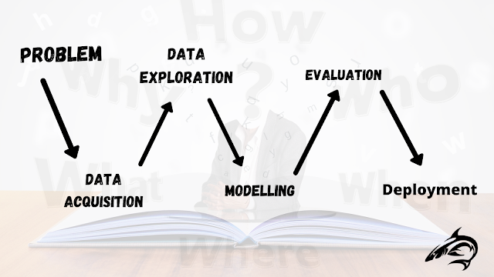

What is AI Project Cycle?

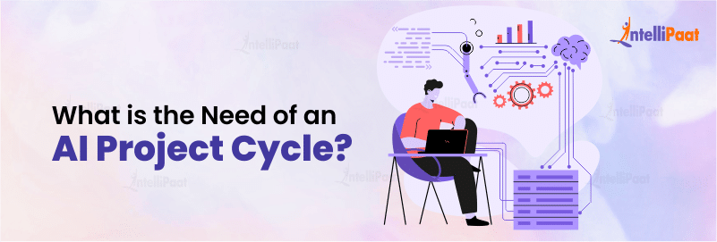

The AI project cycle refers to the step-by-step process that an organization or a person should follow to develop and deploy an[**artificial intelligence**](https://intellipaat.com/blog/what-is-artificial-intelligence/) (AI) project while solving a problem. It is also called the AI development lifecycle. It provides us with an appropriate framework that helps us to achieve our goal.

**Problem Scoping**

Problem scoping is the process of pinpointing a particular issue or opportunity that can be tackled using artificial intelligence (AI). During this phase, we not only identify the problem but also set specific objectives, goals, and criteria for success. However, scoping a problem is no simple task. It requires a deep understanding of the issue so that we can work effectively and solve [**problem-solving**](https://intellipaat.com/blog/what-is-problem-solving/#:~:text=Problem%2DSolving%20aims%20to%20identify,with%20innovative%20solutions%20to%20challenges.).

**The 4Ws Problem Canvas :**

1. Who
2. What
3. Where
4. Why

**4W’s Canva Template :**

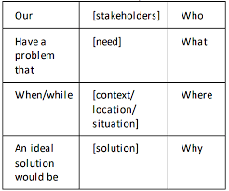

**Who?**: This question identifies the people or groups who are involved in or affected by the problem.

• Who are the stakeholders (e.g., customers, employees, partners)

• Who is responsible for solving the problem?

• Who might benefit from the solution?

**What?:**Refers to what the problem is and what you know about the problem. What is the nature of the problem? Can it be explained simply?

• What exactly is the issue or challenge?

• What are the symptoms or signs of the problem?

• What are the measurable outcomes or indicators of the problem?

**Where?:** We have identified the stakeholders and the nature of the problem, we must investigate where and when it occurs. This information will give us a better understanding of the situation and help us identify patterns and trends.

* Where is the problem occurring (e.g., specific location, department, market)

**Why?:** Refers to the reason we need to solve the problem, the benefits which the stakeholders would get from the solution and how would it benefit them as well as the society, what are the benefits to the stakeholders after solving the problem.

**Data Acquisition:**

Data acquisition is the process of collecting and measuring information on variables of interest in a systematic and structured manner to answer research questions, test hypotheses, or evaluate outcomes. This process involves several steps to ensure that the data gathered is accurate, reliable, and relevant to the objectives at hand.

**Data Exploration :**

Data exploration is the initial step in the data analysis process, where analysts and data scientists gather, describe, and visualize data to understand its structure, content, and patterns. At this stage, you try to interpret some useful information out of the data you have acquired.

Understanding Data Quality: Assessing the completeness, accuracy, and reliability of the data.

Gaining Insights: Identifying key trends, patterns, and anomalies that may inform further analysis.

**Modelling :**

Modelling is the process of creating a mathematical representation of a real-world scenario or system using data and algorithms to make predictions, understand relationships, and generate insights. In the context of data science and machine learning, modelling involves selecting, training, and evaluating algorithms to best capture patterns and relationships in data.

**Evaluation:**

Evaluation is a crucial step in the modelling process that involves assessing the performance and effectiveness of a model. The goal of evaluation is to determine how well a model generalizes to new, unseen data and to identify any areas for improvement. This step helps ensure that the model is reliable, accurate, and suitable for deployment in real-world applications.

* **Precision**: Precision helps us understand how good the model is at avoiding false alarms. It measures the proportion of correctly predicted positive cases out of all the positive predictions the model made.
* **Accuracy**: Accuracy gives us an overall view of the model’s correctness. It calculates the percentage of correct predictions (both true positives and true negatives) over the entire dataset.

**Deployment :**

Deployment is the phase in the data science and machine learning lifecycle where a trained and evaluated model is put into production, making it accessible for real-world use. This step involves integrating the model into existing systems, ensuring it can handle new data and provide predictions or insights as required.

Displaying over :

1. Mobile Applications
2. Servers
3. Webpages/Websites

4W’s Canvas(PROBLEM: Deaf and Nonspeaking Communication)

|  |  |  |
| --- | --- | --- |
| **OUR** | **[stakeholders]**  Primary Stakeholders   * Deaf and Nonspeaking Individuals * Families and Caregivers   Secondary Stakeholders   * Friends and Social Circles * Educational Institutions * Employers and Colleagues * General Public | **WHO** |
| HAS/HAVE  PROBLEM THAT | **[ problem]**  The problem is that individuals who are deaf and nonspeaking face significant challenges in communicating effectively with others, especially in environments where sign language is not understood or accessible. | WHAT |
| WHEN/WHILE | **Education:** Difficulty in classroom participation and accessing learning materials.  **Employment**: Challenges in job interviews, workplace communication, and career advancement.  **Public services:** Barriers in accessing services like transportation, legal aid, and emergency services. | WHERE |
| AN IDEAL SOLUTION WOULD  BE. | Advances in technology and growing awareness of inclusivity provide an opportunity to address these communication barriers effectively. | WHY |